
3  Pork Taco    Pinto Beans  Spanish Rice  Cantaloupe | 4  Greek Lemon Chicken Soup  Green Beans  Toast  Peaches | 5  Baked Fish    Potato Wedges  Coleslaw  Hush Puppies  Papaya | 6  Shephard’s Pie  Side Salad  Biscuit  Fresh Fruit | 7 November Birthdays  Chicken Poblano Soup  Carrots    Corn Bread Muffin  Pears
10 Veteran’s Day Luncheon\  Meat Loaf  Mashed Potatoes    Fall Vegetable  Roll  Dessert |   11  CLOSED FOR VETERAN’S DAY | 12  Beef Stroganoff  Peas & Carrots  Chef’s Choice Veg  Biscuit  Mixed Berries & Cream | 13  Herb Roasted Pork  Mashed Potatoes    Winter Blend Veg  Garlic Toast  Mandarin Oranges | 14  Orange Chicken w/ Rice  Stir Fry Veg blend  Egg Roll  Fresh Fruit
17  Fish w/ Lemon Cream Sauce  Rice    Italian Blend Veg  Yellow Squash  Garlic Bread  Banana | 18  Chicken & Dumplings  Green Beans  Mandarin Oranges | 19  Smokey Pork Pizza  Roasted Mixed Veg  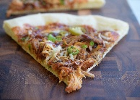  Coleslaw  Cantaloupe | 20  Jambalaya  Broccoli  Garlic Bread  Pears | 21 Thanksgiving Luncheon  Roasted Turkey  Mashed Potatoes  Green Bean Casserole    Stuffing  Roll  Dessert
24  Ground Beef and Cabbage  California Veg Blend  Biscuit  Peaches | 25  Pulled Pork Sandwich  Potato Wedges    Chef’s Choice Veg  Applesauce | 26  Shrimp Stir Fry w/Rice  Stir Fry Veg Blend  Egg Roll  Fresh Fruit |   27 CLOSED |   28 CLOSED
 | 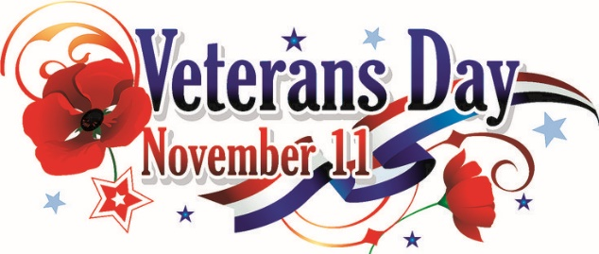 |  |  | Please call 24 hours in advance to make a reservation

